Practice Questions

MCQs

If 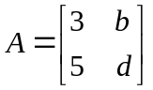 , then which of the following is the determinant of  ?

(a) 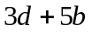
(b) 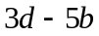 Correct
(c) 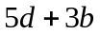
(d) 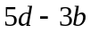

If the matrix 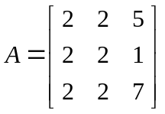 , then which of the following is true about it?

(a) Its determinant is 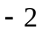 .
(b) Its determinant is . Correct
(c) Its determinant is .
(d) The information is not sufficient to calculate the determinant .

Short

Question No. 1. If the following system of linear equations is solved using the Jacobi’s method, then construct the matrix from the coefficient matrix of the following linear system:

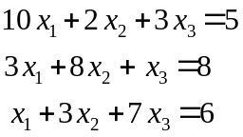
Answer: 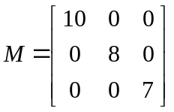

Question No. 2. If the first iteration 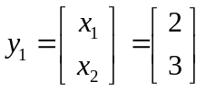 , then use the Jacobi Iteration to find next two iterations of the following system of equations:

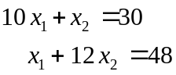

Answer: 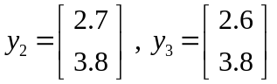
Question No. 3. Evaluate the determinant 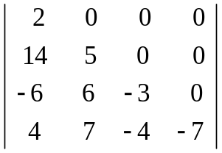 .

Answer: 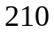

Long
Question No. 4. Verify that 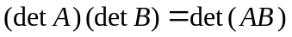, where 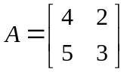 and 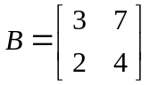.

Answer:

Det(A) = 2
Det(B)= -2
Det(AB)=-4
(Det A)(Det B) = (2)(-2) = -4 =Det(AB)

